DK Dental 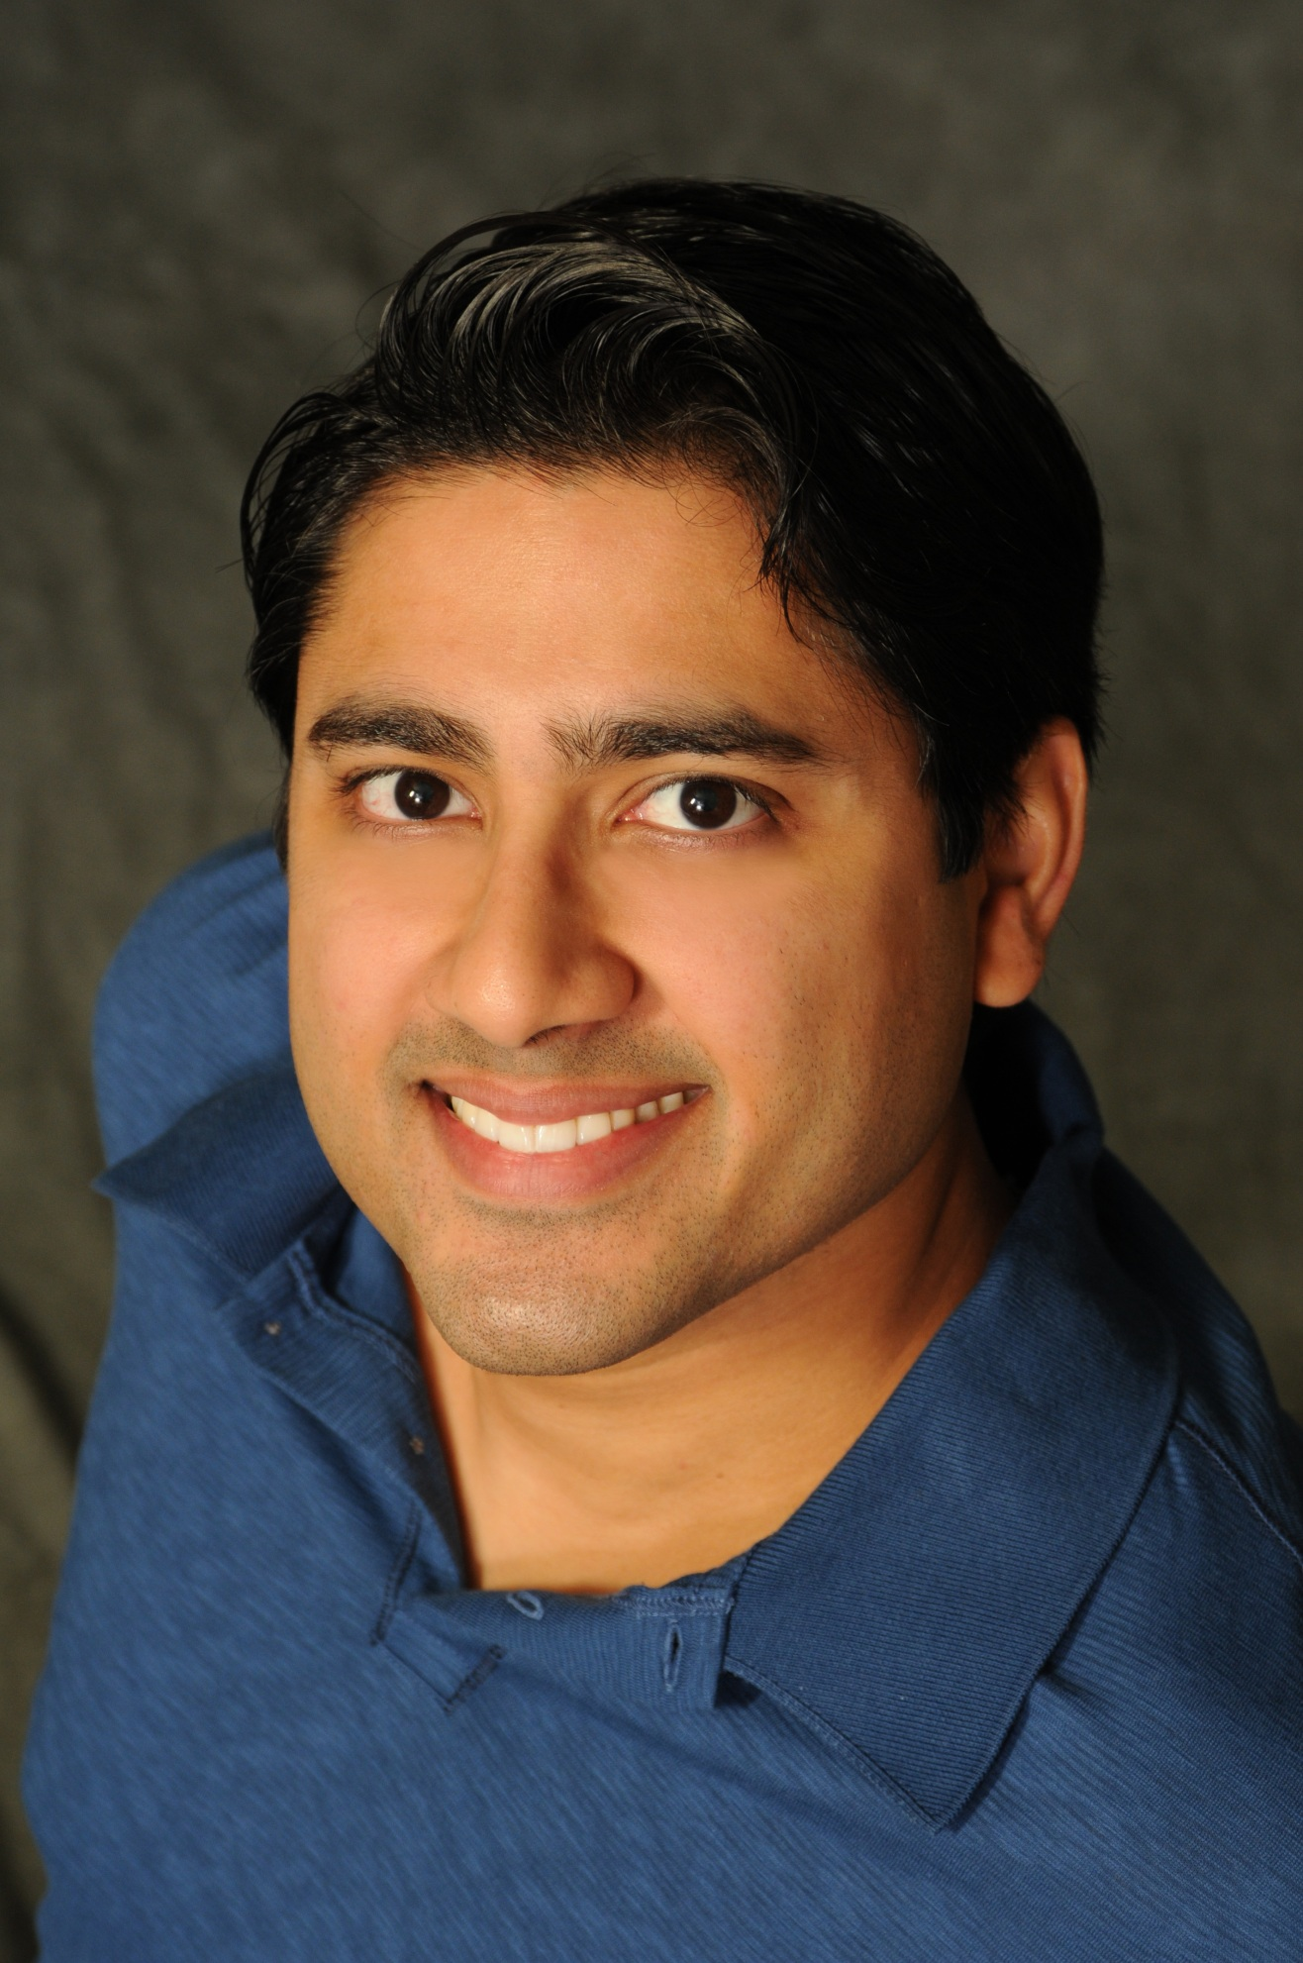
Denesh K. Khullar, D.D.S., P.A.
www.dksmile.com

Welcome to our office, my team and I would like to get to know you better!

Date _________________
Name ________________________________________________________________
Date of Birth _________________ Marital Status _____________________________
Home Address__________________________________________________________
______________________________________________________________________
Home Phone ________________________ Cell Phone __________________________
E-mail address __________________________________________________________
Occupation _____________________________________________________________
Employer _______________________________________________________________
Employer Phone Number ___________________________________________________
Spouse’s Name ___________________________________________________________
Spouse’s Occupation _______________________________________________________
Spouse’s Employer ________________________________________________________
Employer Phone Number ____________________________________________________
Whom may we thank for referring you or how did you find out about us? (Circle One)
Friend/Family Yellow Page Ad Internet Search Insurance Listing Other
If other or friend/family please specify: ____________________________________________
Person financially responsible for this account _______________________________________
Do you have a dental benefit plan? ______ If yes, carrier _______________________________
Medical History

Do you have any general health problems? Yes No
If so, please specify _____________________________________________________________

Are you currently under the care of a physician? Yes No
Reason _______________________________________________________________________
Name and phone number of physician? ______________________________________________

Are you currently taking any drugs or medications? Yes No
If so, please list:________________________________________________________________
_____________________________________________________________________________

To the best of your knowledge, are you or have you ever been afflicted with any of the following? (Circle all that apply)

High Blood Pressure Diabetes Mitral Valve Prolapse Heart Murmur
Heart Disease Artificial Joints/Knee/Hip Respiratory Disease Blood Thinners
Healing Complication Epilepsy/Seizures Rheumatic Fever HIV/AIDS
Hepatitis Liver Disease Osteoporosis Kidney Disease
Stroke Bypass Surgery/Stents Arrhythmias Organ Transplant
Blood Transfusion Asthma Sinus Infections Latex Allergy
Pacemaker Cancer Radiation or Chemotherapy Defibrillator
Temporal Arteritis Pregnant Steroid Therapy Dialysis Shunt

Have you had any surgeries? If so, please list _________________________________________
Do you have any known drug allergies? Yes No
If so, please list ________________________________________________________________

Dental History

When was your last dental visit? __________________________________________________
What did you have done? ________________________________________________________
How long since your last thorough examination with full mouth x-rays? ___________________
What prompted you to seek dental care at this time? ___________________________________
Why did you leave your last dentist? _______________________________________________
What kind of treatment would you like? (Circle One)
Good - Basic care addressing your dental health issues
Best – Ideal treatment, the best available treatment in dentistry today addressing all your functional, cosmetic, and neuromuscular issues

Do you have any pain in your mouth at this time? Yes No
Do you have any TMJ pain? Yes No
Do you have headaches or neck pain? Yes No
Do you have muscle spasms or jaw pain? Yes No
Have you ever had any teeth removed? Yes No
How long have these teeth been missing? ___________________________________________
Do you want to replace any of your missing teeth? Yes No
Are you dissatisfied with your teeth in any way? Yes No
Are you dissatisfied with the way your teeth look?
For example: color, shape, spaces, etc. Yes No
Do you ever avoid any part of your mouth while chewing? Yes No
Are your teeth sensitive to heat, cold, sweets, or biting pressure? Yes No
Does food constantly get stuck between certain teeth in your mouth? Yes No
If any of your mercury amalgam fillings need replacement, would you
prefer to have a more natural, tooth-colored restoration instead? Yes No

Do you get frustrated because you always have something to be treated
or repaired when you visit a dentist? Yes No
Do you want to learn to control dental disease and retain your teeth? Yes No
Has the fear of discomfort kept you from regular dental visits? Yes No
Are you deeply concerned about the finances required to return your
mouth to excellent dental health? Yes No
How often do you brush your teeth? ________________________________________________
How often do you use floss? ______________________________________________________

Is there anything not listed above that you would like to discuss with Dr. Khullar?
If so, please specify: ________________________________________________
_________________________________________________________________

I agree that I have provided my personal, medical, and dental history to the best of my knowledge. I further agree that I am the person financially responsible for my account.
*If you are not financially responsible for your account we will need the signature of the person who is responsible for your account*
Printed Name __________________________________________________________
Signature _____________________________________ Date ____________________

